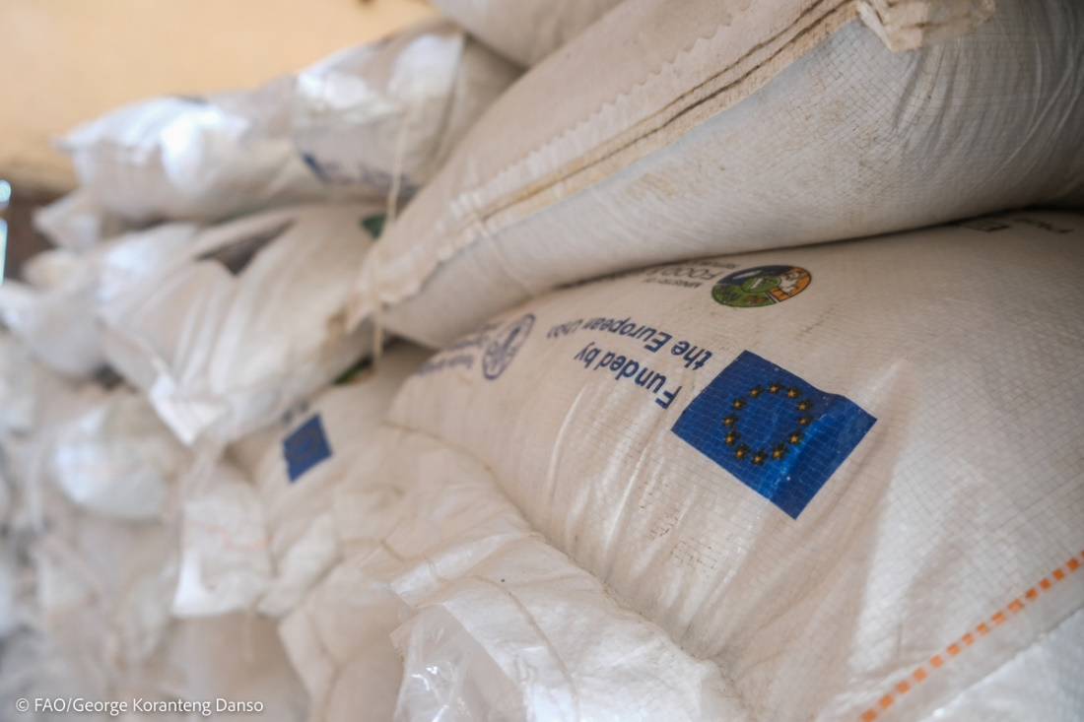

**Press Release**

**The EU Food Security Response: 12,600 smallholder farmers receive agricultural inputs in northern Ghana**

**23 May 2024, Accra** – The European Union (EU), the Food and Agriculture Organization of the United Nations (FAO) and the Government of Ghana have delivered 118,000 kg of maize seeds, 3,000 kg of sorghum foundation seeds, and 540 kg of millet foundation seeds to support12,600 smallholder farmers in the Bunkpurugu-Nakpanduri, Central Gonja, North Gonja, Northeast Gonja, Bongo, and Kasena Nankana West Districts in the Northern Region of Ghana.

Under the EU Food Security Response project, funded by the European Union and facilitated by FAO Ghana in collaboration with Ghana’s Ministry of Food and Agriculture, 31,200 bags of 50 kg NPK fertilizer and 14,000 bags of 50 kg urea fertilizer have also been delivered to support the farmers for the 2024 planting season.

Atintono Joseph, a farmer in the Bongo District, said that the previous unavailability of adequate fertilizers and high-quality seeds had adversely affected crop yields. “The fertilizers and seeds will now enable me to increase crop yields and ensure successful cultivation,” he said.

"This initiative underscores our unwavering commitment to enhancing food security and empowering local communities," said Arslen Bounemra, FAO Representative in Ghana. "We are proud to collaborate with the Ministry of Agriculture and the European Union to deliver essential agricultural inputs to farmers in Northern Ghana."

The European Union Ambassador to Ghana, Irchad Razaaly, said: “By combining our resources and expertise, the EU and FAO, in partnership with the Government of Ghana, are working together to ensure that farmers have access to high-quality seeds and other vital inputs necessary for successful crop cultivation for the 2024 planting season. This initiative is part of our broader mission to empower smallholder farmers, improve food security, and promote sustainable agricultural practices," he said.

This distribution exemplifies the project's dedication to enhancing agricultural productivity and food security in Northern Ghana. By equipping farmers with quality seeds, fertilizers, and equipment, the project aims to strengthen resilience and promote sustainable development within local farming communities.

**End**

For media inquiries, please contact:

**George Koranteng Danso**

Digital Communication Specialist

FAO Ghana

[George.korantengdanso@fao.org](mailto:George.korantengdanso@fao.org)

+233 (0)24 5640024

**Abdul-Kudus Husein**

Press and Information Officer

European Union in Ghana

[Abdul-Kudus.HUSEIN@eeas.europa.eu](mailto:Abdul-Kudus.HUSEIN@eeas.europa.eu)

+233 (0)20 1889118

**Note to Editors:**

* The world is facing a global food crisis, aggravated by the war in Ukraine. The latest Global Report on Food Crises estimates that up to 282 million people face high levels of acute food insecurity in 59 countries.
* In 2022, in a “Team Europe” approach, the European Commission mobilised €600 million from the reserves of the European Development Fund to address the food security crisis. This response was unanimously agreed in record time by all 27 EU Member States.
* As part of the Team Europe’s Response to Global Food Insecurity, the funding aims at supporting people in African, Caribbean and Pacific countries, where the humanitarian needs are the highest and where programmes to sustainably enhance food security and resilience were identified. It includes four strands of action to be implemented jointly with the Member States: 1. Solidarity: emergency relief and affordability; 2. Sustainable production and resilience; 3. Trade: facilitating food trade; 4. Effective multilateralism.
* With the additional €600 million, the EU envisages to allocate for food security and food systems programmes in partner countries of €7.7 billion worldwide. This also includes an estimated €2.2 billion in immediate humanitarian food and nutrition assistance for the most vulnerable countries and a further €5 billion to invest in the medium to longer term in sustainable food systems.