PRESS RELEASE

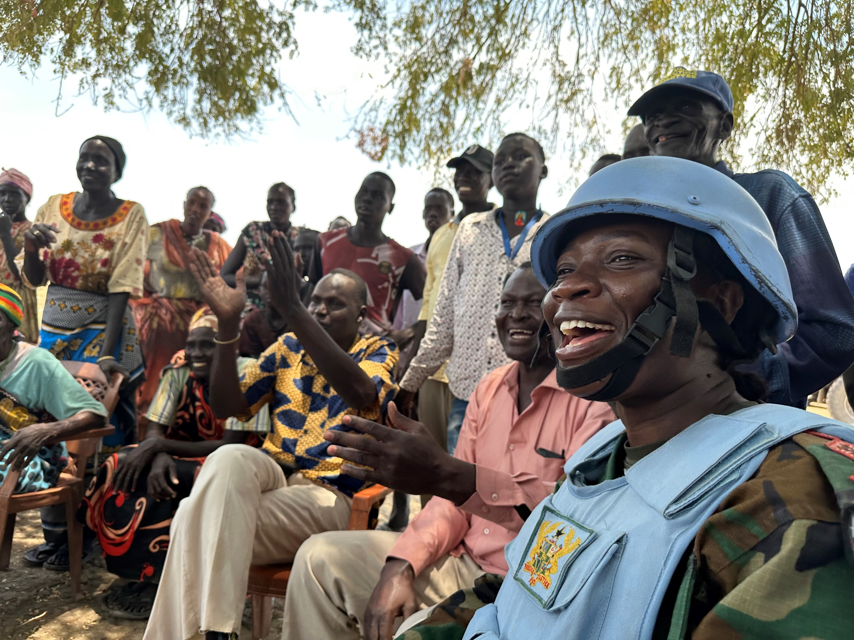

Ghanaian peacekeeper selected as United Nations Military Gender Advocate of the Year 2022

New York, 22 May 2023 - A Ghanaian peacekeeper serving with the United Nations Interim Security Force in Abyei (UNISFA) will receive the 2022 United Nations Military Gender Advocate of the Year Award.

Captain Cecilia Erzuah, 32, who has served in Abyei since March 2022 as the Commander of the Ghana Engagement Platoon, will receive the award from Secretary-General António Guterres during a ceremony marking the International Day of UN Peacekeepers on Thursday, 25 May 2023.

Created in 2016, the United Nations “Military Gender Advocate of the Year Award” recognizes the dedication and efforts of an individual military peacekeeper in promoting the principles of UN Security Council Resolution 1325 on Women, Peace and Security.

“Resolution 1325 reminds us that our women peacekeepers are not only supporting global peace and security. They are leading the way. By every measure, Captain Cecilia Erzuah of Ghana is one of those leaders,” said Secretary-General António Guterres. “On every front, Captain Erzuah’s work has set the standard for ensuring that the needs and concerns of women are reflected across our peacekeeping operations.”

Captain Erzuah expressed her gratitude for being selected to receive the prize which she called “an award for all of us,” referring to her platoon members.

An advocate for gender equality and community engagement, Capt. Erzuah made sure that her 22-strong platoon, composed equally of men and women, conducted regular patrols and outreach to local leaders as well as women’s and youth groups, to better understand and address community concerns and needs. Together with civilian UN colleagues, she also hosted discussions on domestic violence, gender equality and childcare. Those conversations resulted in an increase in the number of women enlisted in Community Protection Committees, which were initially male dominated. The engagement with community members led to improved early warning about threats of violence against civilians and broader security issues.
The monthly market walks she initiated with her battalion also contributed to build strong and enduring relationships between traders, local residents and the UN.

In January 2023, following a spike in community violence in Majbong, a village in southeast Abyei, Captain Erzuah’s platoon stepped up its presence, regularly checking on the plight of displaced people in the volatile area and enabling the Mission to provide necessary support. Community members, who had sought sanctuary from the fighting in the surrounding bush, gradually began returning to their homes in the village and women reported feeling much safer. “The mixed patrols are (...) boosting the confidence of members of the community to go about daily activities safely,” said Deng Paul Mankuol, a traditional chief in Majbong.

Captain Erzuah is the first Ghanaian peacekeeper, and the first recipient from a contingent or a unit, to receive this prestigious award. Ghana is currently the largest contributor of women military peacekeepers to the United Nations with 375 now deployed.

* * * *
About the awardee: Born in Kumasi, Ghana, in 1990, Captain Erzuah joined the Ghana Armed Forces in 2016. One year later, she was posted to the Directorate of Military Records as a Records Officer. She served for the first time under the UN flag with the United Nations Interim Force in Lebanon (UNIFIL) as a Records Officer from July 2019 to August 2020. In March 2022, she was deployed to the United Nations Interim Security Force in Abyei (UNISFA) as Commander of the Ghanaian Engagement Platoon.

Note to the editors: The Military Gender Advocate of the Year Award is underpinned by the principles outlined in United Nations Security Council Resolution 1325 and follow-on resolutions on Women, Peace and Security. The resolutions call on actors to mainstream a gender perspective in all aspects of peacekeeping and peacebuilding and to ensure women’s participation in peace and political processes. They also call for the protection from, and prevention of, conflict-related sexual violence and for an expansion of the role and contribution of women in UN operations, including of uniformed women peacekeepers.

Find out more about the award here: https://peacekeeping.un.org/en/gender-advocate-of-year-award
Photos and digital assets are available for download here: https://trello.com/c/Kl8QFD2W/104-military-gender-advocate-of-the-year-2022

* * * *
Media contacts:
Douglas Coffman – UN Department of Global Communications
Tel.: +1 (917) 361-9923 E-Mail: coffmand@un.org
Sophie Boudre – UN Department of Peace Operations
Tel.: +1 (917) 691-5359 E-Mail: boudre@un.org
For requests in Ghana: Cynthia Prah - UN Information Centre in Accra
Tel.: +233 556 783 033 E-Mail: prah@un.org

