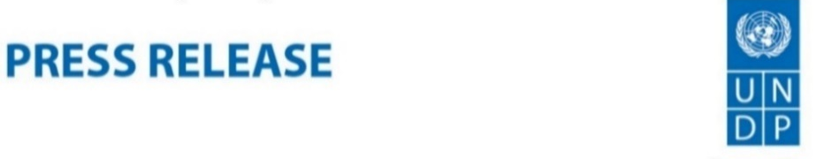
5
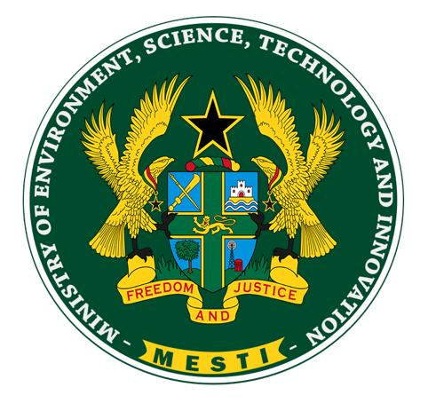

Ghana commits to implementing its ambitious climate actions by launching a revision process

Accra, 1st September 2020 - The Government of Ghana, through the Ministry of Environment, Science, Technology and Innovation (MESTI), has launched the revision process of Ghana's Nationally Determined Contributions (NDCs) to strengthen the implementation of national priorities on climate change adaptation and mitigation to achieve low carbon development in the country.

The revision offers a good opportunity for Ghana to raise its ambition and integrate emerging policies into climate change actions at the national level.

Speaking at the launch, the Minister of Environment, Professor Kwabena Frimpong-Boateng reiterated Government’s commitment to the revision and called on all stakeholders including the private sector, civil society organizations, relevant Metropolitan, Municipal and District Assemblies (MMDAs) and development partners to support the process.

“The official launch today demonstrates the political support for the NDCs revision and Ghana’s commitment under the Paris Agreement. I call on all stakeholders to therefore support this worthy course to build a prosperous and climate resilient economy to promote sustainable development for our dear nation”, noted Prof. Frimpong-Boateng.

He added that though the implementation of the country’s 2016 NDC experienced various challenges including inadequate funding, technological barriers, and limited capacity among others, there have been significant progress and achievements. The successes, according to him, include the recent approval of $54.5million from the Green Climate Fund (GCF) to help communities in Northern Ghana adapt to climate change; and completion of 5 mini-grids in Pediatorkope, Atigagome, Wayokope, Aglakope and Kudorkope, serving about 10,000 people and providing a total of 1.7 MW of installed power capacity. He also cited partnerships with government of Switzerland to develop projects to generate mitigation outcomes in exchange for payment in line with Article 6 of the Paris Agreement.

Highlighting the challenges posed by COVID-19 on the climate change agenda, the Deputy Resident Representative of the United Nations Development Programme (UNDP) in Ghana, Ms. Silke Hollander observed that, the response to the pandemic and green recovery efforts also present a window of opportunities to build back better and design bold and long-term climate actions.

“I am confident that the NDCs revision and enhancement process will take into consideration the COVID-19 reality and its associated impacts across all sectors”.

Consistent with Article 4.9 of the Paris Agreement on successive updates every five years, Ghana is one of the pioneers to start its NDCs revision process. The revised nationally determined contribution is expected to include consideration of new and emerging policies; inclusion of missing or new technologies that lower "carbon-lock-in" and reduce the cost of transition; the need to bring sub-national non-state actors on board; and provision for details on investment needs and approaches to drive finance.

The revision process falls under the NDC Support Programme, which has been UNDP’s primary mode of support to countries to support NDCs implementation readiness and institutional capacity. The programme is being implemented in partnership with the Federal Ministry for the Environment, Nature Conservation, Building and Nuclear Safety (BMU), the Federal Ministry of Economic Cooperation and Development (BMZ), European Union, and the Spanish Agency for International Development Cooperation (AECID).
###

For media enquiry, please contact:

UNDP: Ms. Praise Nutakor: Head of Communications of UNDP Ghana at: praise.nutakor@undp.org , Tel: +233-501323566

MESTI: Mr. Nasir Ahmad Yartey, Head, of Public Relations at: nasirahmadyartey@gmail.com, Tel: +233-244501808

About United Nations Development Programme (UNDP)
UNDP is the leading United Nations organization fighting to end the injustice of poverty, inequality, and climate change. Working with our broad network of experts and partners in 170 countries, we help nations to build integrated, lasting solutions for people and planet. on Twitter. Kindly visit www.gh.undp.org or follow @UNDP/ @UNDPGhana on Twitter/Facebook for further information.

